**8-BIT SUBTRACTION**  
  
  
**EXP NO: 2**  
  
**AIM:**To write an assembly language program to  
implement 8-bit subtraction using 8085 processor.

**ALGORITHM:**  
  
  
1)      Start  
the program by loading the first data into the accumulator.

2)      Move  
the data to a register.  
  
3)      Get  
the second data and load it into the accumulator.  
  
4)      Subtract  
the two register contents.  
  
5)      Check  
for borrow.  
  
6)      Store  
the difference and borrow in the memory location.  
  
7)      Halt.

**PROGRAM:**  
  
  
          LDA 8000  
  
  
          MOV B, A  
  
  
          LDA 8001  
  
  
          SUB B  
  
  
          STA 8002  
  
  
          RST 1  
  
  
  
**INPUT:**  
  
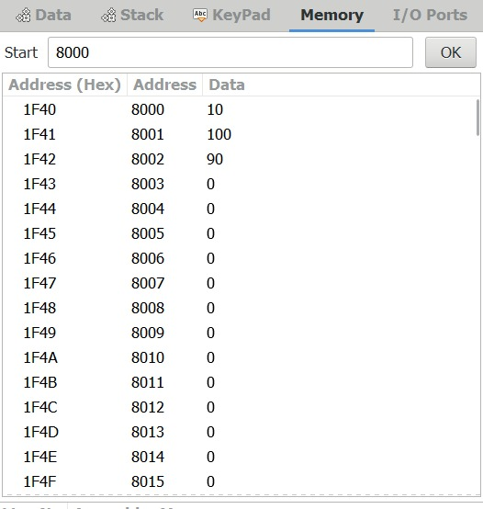  
   
  
  
**OUTPUT:**

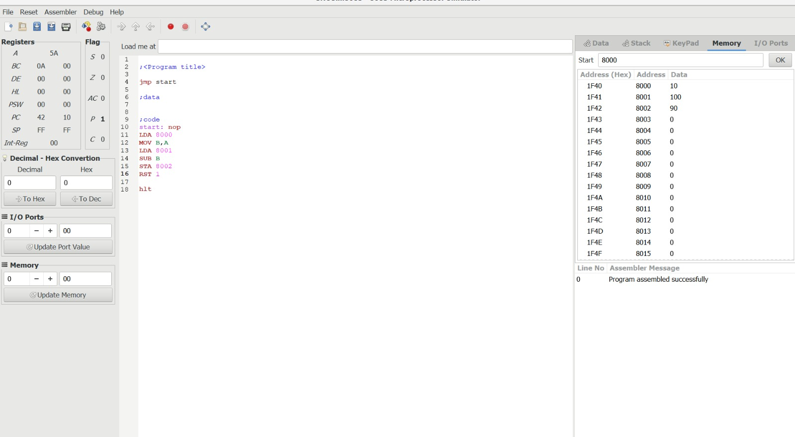  
  
  
  
  
**RESULT:**Thus  
the program was executed successfully using 8085 processor simulator.